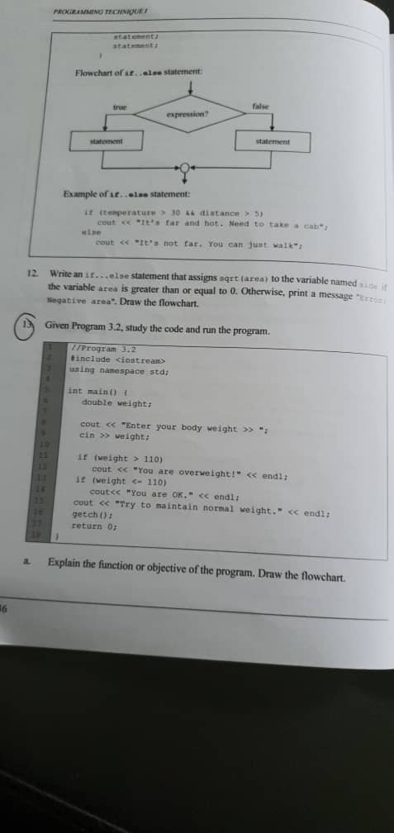

a) Function or Objective : Do determine whether the weight is overweight or not.

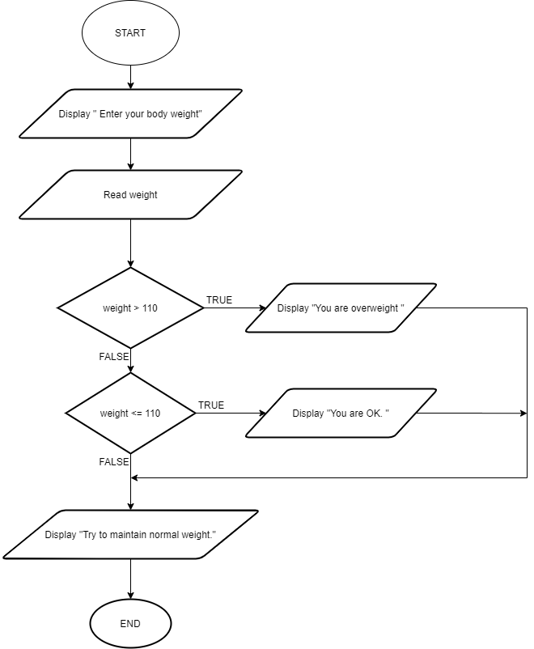

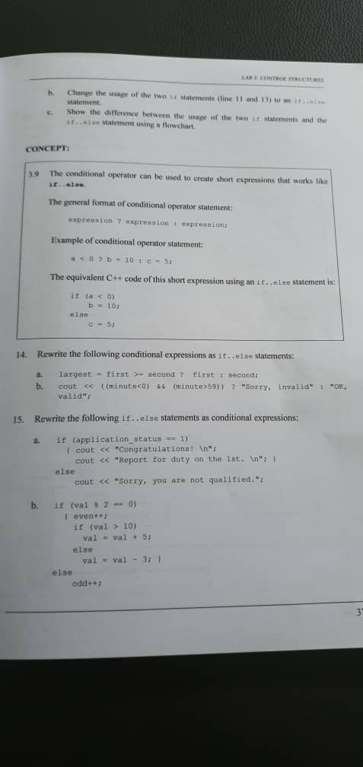

b) If ( weight > 110 )

cout << “You are overweight! “ << endl;

else

cout << “You are OK. “ << endl;

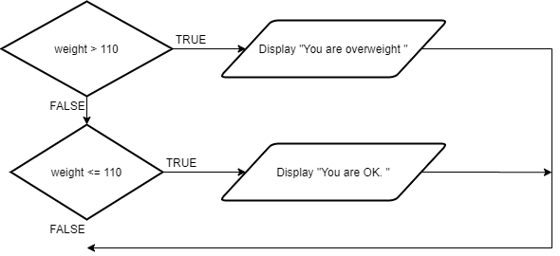c)

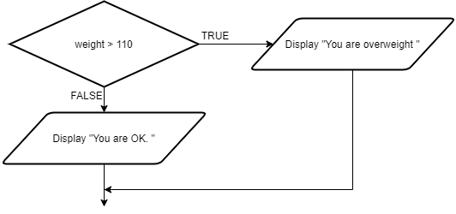 If statement

If … else statement